<https://en.cppreference.com/w/cpp/container>

<https://stackoverflow.com/questions/471432/in-which-scenario-do-i-use-a-particular-stl-container>

The goal: to figure out what data structure would fit for making an inventory system for Zorkish adventure.

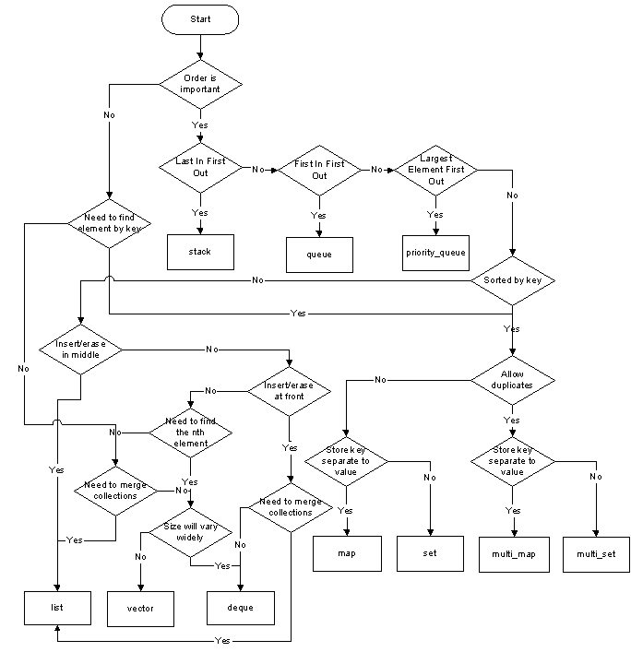

What a Zorkish adventure inventory should be able to do:

* Store
* Search/Display
* Search/Remove
* Stretch features
  + Auto sorting
  + Static inventory?

Expectations: Will be using an array for this. It’s as easy as going to the indexed slot and get the item out

There are a few containers that can be used to create the inventory system

Array:

* Has fixed size, changing size requires creating a new array with new size then copy old contents over
* Access to any element is O(1)

List:

* Dynamic growth
* Access to any element except the first and last is O(n)

Map: